

NAME | Ranadip Paul
UNIVERSITY ROLL NO. | 23442724071
PAPERNAME | PHP WITH MYSQL LAB
PAPERCODE | [BCAC 591]
COLLEGE NAME | BHAWANIPUR GLOBAL CAMPUS
COLLEGE CODE | 234

INDEX

Assignment | Q. | Program / Question | Page
Assignment 1 | 1 | Get PHP version and configuration information | 5
Assignment 1 | 2 | Accept username through HTML form and display it | 6
Assignment 1 | 3 | Get the client IP address | 7
Assignment 1 | 4 | Simple PHP browser detection script | 7
Assignment 1 | 5 | Get the current file name | 8
Assignment 1 | 6 | Return components of the given URL | 8
Assignment 1 | 7 | Check whether the page is called from HTTPS or HTTP | 9
Assignment 1 | 8 | Redirect a user to a different page | 10
Assignment 1 | 9 | Check whether an email is valid | 11
Assignment 1 | 10 | Display strings and values within a table | 11
Assignment 1 | 11 | Get information about the operating system PHP is running on | 13
Assignment 1 | 12 | Get the last occurred error | 13
Assignment 1 | 13 | Check whether a number is even or odd using user input | 14
Assignment 1 | 14 | Calculate circumference and area of a circle | 15-16
Assignment 1 | 15 | Calculate the grade/class from student marks | 16-17
Assignment 1 | 16 | Count a search word in a user-input paragraph | 18
Assignment 1 | 17 | User registration with validation | 19-20
Assignment 2 | 1 | Check whether three integers are in the range 20..50 | 22
Assignment 2 | 2 | Find which number is nearest to 100 | 23
Assignment 2 | 3 | Check whether two integers are in the ranges 40..50 or 50..60 | 24
Assignment 2 | 4 | Convert the last 3 characters of a string to uppercase | 25
Assignment 2 | 5 | Count the string "aa" in a given string | 26
Assignment 2 | 6 | Check whether a specified number is present in an array | 27
Assignment 2 | 7 | Check whether a string starts with "F" or ends with "B" (Fizz/Buzz) | 28
Assignment 2 | 8 | Insert a given string into the middle of another 4-character string | 30
Assignment 2 | 9 | Create long + short + long string from two given strings | 31
Assignment 2 | 10 | Rotate a 4-element array in the left direction | 32

Assignment – 1 PHP With MYSQL

Get PHP version and configuration information
<?php phpinfo();
?>

Output:

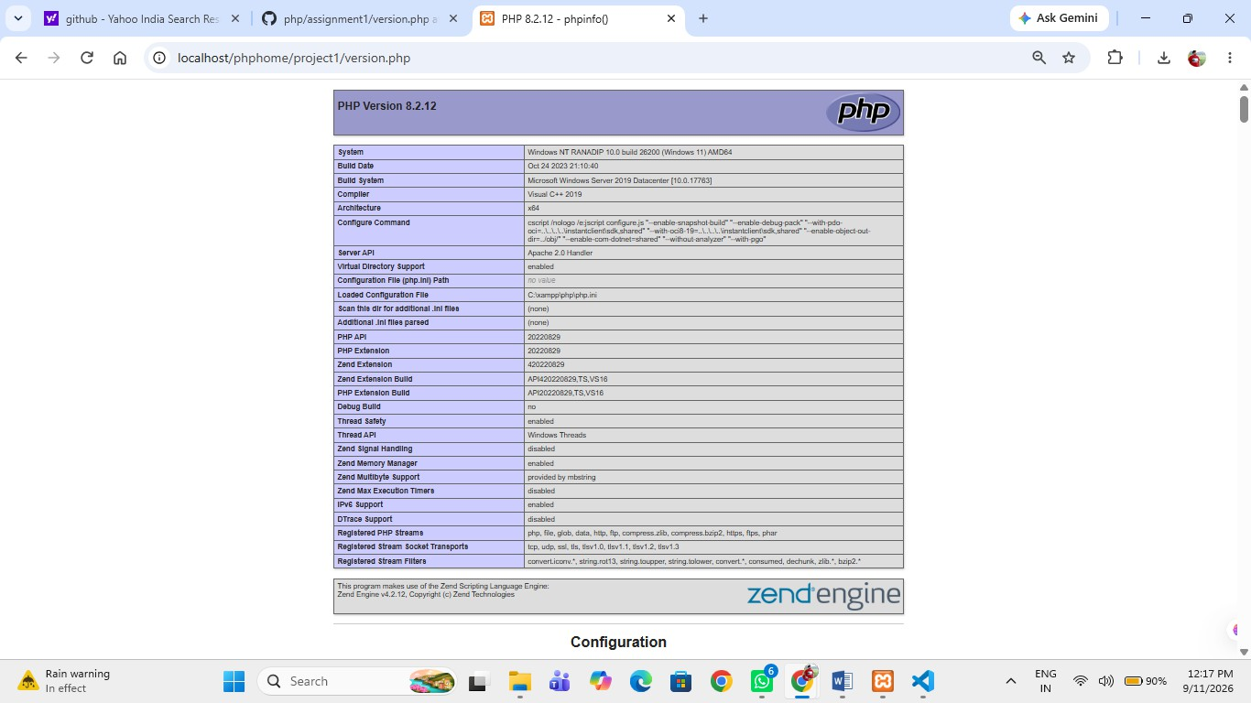

Accept username through HTML form and display it
<!DOCTYPE html>
<html>
<body>
<form method="post">
Enter Name: <input type="text" name="username" required>
<input type="submit" value="Submit">
</form>

<?php
if ($_SERVER["REQUEST_METHOD"] == "POST") {
echo "Your name is: " . htmlspecialchars($_POST["username"]);
}
?>
</body>
</html>

Output:
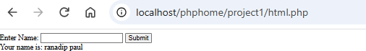

Get the client IP address
<?php

echo gethostbyname(gethostname());

?>

Output:


Simple PHP browser detection script
<?php
$userAgent = $_SERVER['HTTP_USER_AGENT'];
echo "Your User-Agent is: " . htmlspecialchars($userAgent);
?>

Output:

Get the current file name
<?php
echo "Current file name: " . basename($_SERVER['PHP_SELF']);
?>

Output:


Return components of the given URL
<?php
$url = 'https://www.w3resource.com/php-exercises/php-basic-exercises.php';
$parts = parse_url($url);

echo "Scheme: " . $parts['scheme'] . "<br>";
echo "Host: " . $parts['host'] . "<br>";

echo "Path: " . $parts['path'];
?>
Output:
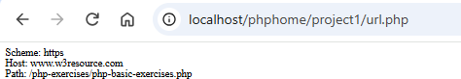

Check whether the page is called from HTTPS or HTTP
<?php
if (isset($_SERVER['HTTPS']) && $_SERVER['HTTPS'] !== 'off') {
echo "The page is called using HTTPS.";
} else {
echo "The page is called using HTTP.";
}
?>


Output:

Redirect a user to a different page
<?php header("Location:
https://www.flipkart.com/"); exit;
?>

Output:
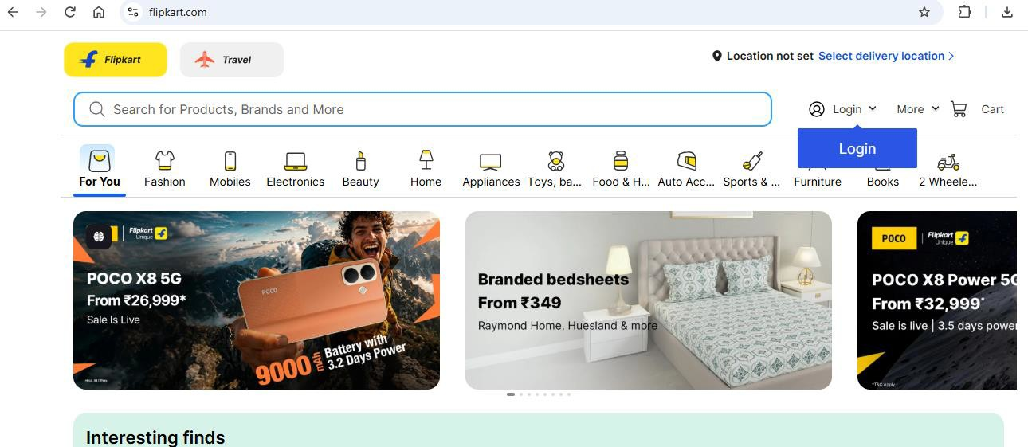

Check whether an email is valid
<!DOCTYPE html>
<html>
<body>
<form method="post">
Email: <input type="text" name="email" required>
<input type="submit" value="Check">
</form>

<?php
if ($_SERVER["REQUEST_METHOD"] == "POST") {
$email = trim($_POST["email"]);

if (filter_var($email, FILTER_VALIDATE_EMAIL)) { echo "Valid email address.";
} else {
echo "Invalid email address.";
}
}
?>
</body>
</html>


Output:

Display strings and values within a table
<?php
$name = "Shankho";
$age = 21;
$course = "BCA";

echo "<table border='1' cellpadding='8'>"; echo "<tr><th>Field</th><th>Value</th></tr>"; echo "<tr><td>Name</td><td>$name</td></tr>"; echo "<tr><td>Age</td><td>$age</td></tr>";
echo "<tr><td>Course</td><td>$course</td></tr>"; echo "</table>";
?>

Output:
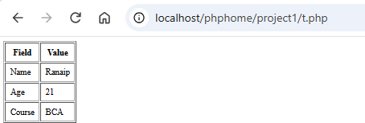

Get information about the operating system PHP is running on
<?php
echo "Operating System: " . PHP_OS_FAMILY;
?>

Output:
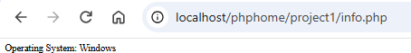

Get the last occurred error
<?php
// Example error
echo $undefinedVariable;
$error = error_get_last(); if ($error !== null) {
echo "<pre>"; print_r($error); echo "</pre>";
} else {
echo "No error has occurred.";
}
?>

Output:
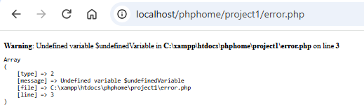

Check whether a number is even or odd using user input
<!DOCTYPE html>
<html>
<body>
<form method="post">
Enter Number: <input type="number" name="number" required>
<input type="submit" value="Check">
</form>

<?php
if ($_SERVER["REQUEST_METHOD"] == "POST") {
$number = (int)$_POST["number"];

if ($number % 2 == 0) { echo "$number is Even.";
} else {
echo "$number is Odd.";
}
}
?>
</body>
</html>

Output:



Calculate circumference and area of a circle

<!DOCTYPE html>
<html>
<body>
<form method="post">
Enter Radius: <input type="number" name="radius" step="any" min="0" required>
<input type="submit" value="Calculate">
</form>

<?php
if ($_SERVER["REQUEST_METHOD"] == "POST") {
$radius = (float)$_POST["radius"];

$circumference = 2 * pi() * $radius;
$area = pi() * $radius * $radius;

echo "Circumference: " . $circumference . "<br>"; echo "Area: " . $area;

}
?>
</body>
</html>

Output:
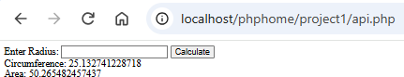

Calculate the grade/class from student marks
<!DOCTYPE html>
<html>
<body>
<form method="post">
Enter Marks: <input type="number" name="marks" min="0" max="1000" required>
<input type="submit" value="Calculate">
</form>

<?php
if ($_SERVER["REQUEST_METHOD"] == "POST") {
$marks = (int)$_POST["marks"];

if ($marks > 800 && $marks <= 1000) { echo "Print";
} elseif ($marks > 600 && $marks <= 800) { echo "Class II";
} elseif ($marks > 400 && $marks <= 600) { echo "Class III";
} elseif ($marks >= 0 && $marks <= 400) { echo "Fail";
} else {
echo "Invalid marks.";
}
}
?>
</body>
</html>

Output:






Count a search word in a user-input paragraph
<!DOCTYPE html>
<html>
<body>
<form method="post">
<label>Paragraph:</label><br>
<textarea name="paragraph" rows="6" cols="60" required></textarea><br><br>

<label>Search Word:</label>
<input type="text" name="word" required>
<input type="submit" value="Search">
</form>

<?php
if ($_SERVER["REQUEST_METHOD"] == "POST") {
$paragraph = $_POST["paragraph"];
$word = trim($_POST["word"]);

if ($word === "") {
echo "Please enter a search word.";
} else {
$count = substr_count(strtolower($paragraph), strtolower($word)); echo "The word '" . htmlspecialchars($word) . "' occurs " . $count . "
time(s).";
}
}
?>
</body>
</html>

Output:
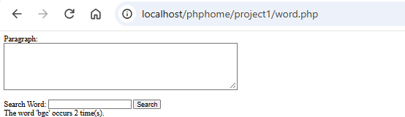

User registration with validation
<!DOCTYPE html>
<html>
<body>
<h2>User Registration</h2>

<form method="post">

Full Name:
<input type="text" name="fullname" required><br><br>

Date of Birth:
<input type="date" name="dob" required><br><br>

Email ID:
<input type="email" name="email" required><br><br>

Mobile:
<input type="text" name="mobile" maxlength="10" required><br><br>

<label>
<input type="checkbox" name="terms"> I agree to the terms and conditions
</label><br><br>

<input type="submit" value="Register">
</form>

<?php
if ($_SERVER["REQUEST_METHOD"] == "POST") {
$fullname = trim($_POST["fullname"]);
$dob = $_POST["dob"];
$email = trim($_POST["email"]);
$mobile = trim($_POST["mobile"]);
$terms = isset($_POST["terms"]);

$errors = [];
if (count(preg_split('/\s+/', $fullname)) < 2) {
$errors[] = "Full name must contain at least two words.";
}
if ($dob === "") {
$errors[] = "Date of birth is required.";
} else {
try {
$birthDate = new DateTime($dob);
$today = new DateTime();
$age = $today->diff($birthDate)->y;

if ($birthDate > $today || $age < 18) {
$errors[] = "User must be at least 18 years old.";
}
} catch (Exception $e) {
$errors[] = "Invalid date of birth.";
}
}
if (!filter_var($email, FILTER_VALIDATE_EMAIL)) {
$errors[] = "Please enter a valid email address.";
}
if (!preg_match('/^\d{10}$/', $mobile)) {
$errors[] = "Mobile number must be exactly 10 digits.";
}

if (!$terms) {
$errors[] = "You must agree to the terms and conditions.";
}

if (empty($errors)) {
echo "<p style='color:green;'>Successful registration</p>";
} else {
echo "<ul style='color:red;'>"; foreach ($errors as $error) {
echo "<li>" . htmlspecialchars($error) . "</li>";
}
echo "</ul>";
}
}
?>
</body>
</html>

Output:
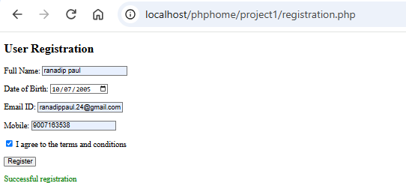

Assignment – 2

PHP With MYSQL

Question 18
Write a PHP program to check whether three given integer values are in the range 20..50 inclusive. Return true if 1 or more of them are in the said range otherwise false.

Code
<!DOCTYPE html>
<html>
<body>
<?php
$result = null;
if ($_SERVER['REQUEST_METHOD'] === 'POST') {
$a = (int)$_POST['a'];
$b = (int)$_POST['b'];
$c = (int)$_POST['c'];

if (($a >= 20 && $a <= 50) || ($b >= 20 && $b <= 50) || ($c >= 20 && $c <= 50)) {
$result = "true";
} else {
$result = "false";
}
}
?>

<h2>Check Range 20..50</h2>
<form method="post">
A: <input type="number" name="a" value="25" required><br> B: <input type="number" name="b" value="10" required><br> C: <input type="number" name="c" value="70" required><br>
<button>Check</button>
</form>
<?php if ($result !== null) echo "<h3>Result: $result</h3>"; ?>
</body>
</html>

Output :

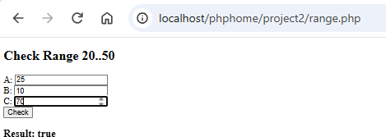

Question 19
Write a PHP program to check which number nearest to the value 100 among two given integers. Return 0 if the two numbers are equal.

Code
<!DOCTYPE html>
<html>
<body>
<?php
$result = null;
if ($_SERVER['REQUEST_METHOD'] === 'POST') {
$a = (int)$_POST['a'];
$b = (int)$_POST['b'];

if ($a == $b) {
$result = 0;
} elseif (abs(100 - $a) < abs(100 - $b)) {
$result = $a;
} else {
$result = $b;
}
}
?>

<h2>Nearest to 100</h2>
<form method="post">
First: <input type="number" name="a" value="90" required><br><br> Second: <input type="number" name="b" value="80" required><br><br>
<button>Check</button>
</form>
<?php if ($result !== null) echo "<h3>Result: $result</h3>"; ?>
</body>
</html>

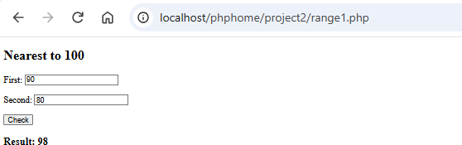
Output

Question 20
Write a PHP program to check whether two given integers are in the range 40..50 inclusive, or they are both in the range 50..60 inclusive.

Code
<!DOCTYPE html>
<html>
<body>
<?php
$result = null;
if ($_SERVER['REQUEST_METHOD'] === 'POST') {
$a = (int)$_POST['a'];
$b = (int)$_POST['b'];

$range1 = ($a >= 40 && $a <= 50 && $b >= 40 && $b <= 50);
$range2 = ($a >= 50 && $a <= 60 && $b >= 50 && $b <= 60);

$result = ($range1 || $range2) ? "true" : "false";
}
?>

<h2>Check Two Numbers in Range</h2>
<form method="post">
First: <input type="number" name="a" value="45" required><br><br> Second: <input type="number" name="b" value="48" required><br><br>
<button>Check</button>
</form>
<?php if ($result !== null) echo "<h3>Result: $result</h3>"; ?>
</body>
</html>

Output:
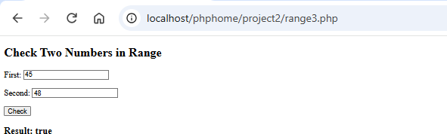

Question 21
Write a PHP program to convert the last 3 characters of a given string in upper case. If the length of the string has less than 3 then uppercase all the characters.

Code
<!DOCTYPE html>
<html>
<body>
<?php
$result = null;
if ($_SERVER['REQUEST_METHOD'] === 'POST') {
$s = $_POST['s'];
$length = strlen($s);

if ($length < 3) {
$result = strtoupper($s);
} else {
$result = substr($s, 0, $length - 3) . strtoupper(substr($s, -3));
}
}
?>

<h2>Uppercase Last 3 Characters</h2>
<form method="post">
String: <input type="text" name="s" value="hello" required>
<button>Convert</button>
</form>
<?php if ($result !== null) echo "<h3>Result: $result</h3>"; ?>
</body>
</html>

Output:
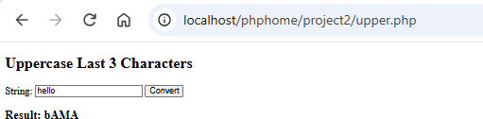

Question 22
Write a PHP program to count the string "aa" in a given string and assume "aaa" contains two "aa".

Code
<!DOCTYPE html>
<html>
<body>
<?php
$result = null;
if ($_SERVER['REQUEST_METHOD'] === 'POST') {
$s = $_POST['s'];
$result = 0;

for ($i = 0; $i < strlen($s) - 1; $i++) { if (substr($s, $i, 2) === "aa") {
$result++;
}
}
}
?>

<h2>Count "aa" in String</h2>
<form method="post">
String: <input type="text" name="s" value="aaa" required>
<button>Count</button>
</form>
<?php if ($result !== null) echo "<h3>Result: $result</h3>"; ?>
</body>
</html>

Output:
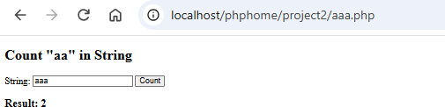

Question 23
Write a PHP program to check a specified number is present in a given array of integers.

Code
<!DOCTYPE html>
<html>
<body>
<?php
$result = null;
if ($_SERVER['REQUEST_METHOD'] === 'POST') {
$arr = array_map('intval', explode(',', $_POST['arr']));
$number = (int)$_POST['number'];

$result = in_array($number, $arr) ? "true" : "false";
}
?>

<h2>Search Number in Array</h2>
<form method="post">
Array (comma separated): <input type="text" name="arr" value="10,20,30,40" required><br><br> Number: <input type="number" name="number" value="30" required><br><br>
<button>Search</button>
</form>
<?php if ($result !== null) echo "<h3>Result: $result</h3>"; ?>
</body>
</html>

Output:
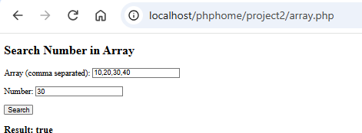

Question 24
Write a PHP program to check whether a given string starts with "F" or ends with "B". If the string starts with "F" return "Fizz" and return "Buzz" if it ends with "B" If the string starts with "F" and ends with "B" return "FizzBuzz". In other cases return the original string.

Code
<!DOCTYPE html>
<html>
<body>
<?php
$result = null;
if ($_SERVER['REQUEST_METHOD'] === 'POST') {
$s = $_POST['s'];
$startsF = strtoupper(substr($s, 0, 1)) === "F";
$endsB = strtoupper(substr($s, -1)) === "B";

if ($startsF && $endsB) {
$result = "FizzBuzz";
} elseif ($startsF) {
$result = "Fizz";
} elseif ($endsB) {
$result = "Buzz";
} else {
$result = $s;
}
}
?>

<h2>Fizz / Buzz</h2>
<form method="post">
String: <input type="text" name="s" value="FAB" required>
<button>Check</button>
</form>
<?php if ($result !== null) echo "<h3>Result: $result</h3>"; ?>
</body>
</html>

Output:
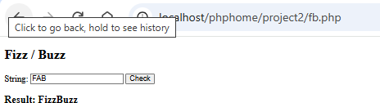

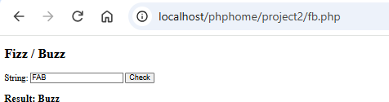

_,, ,,., uu.. =._...,,lo,,.c.,_al.,_,h""ocaist/phphome/project2/fb.php
Click to go back, hold to see histo,y

Fizz/Buzz
String:cclFABc.c::.... ,uCl,eci( I
Result: Fizz

Question 25
Write a PHP program to insert a given string into middle of the another given string of length 4.

Code
<!DOCTYPE html>
<html>
<body>
<?php
$result = null;
if ($_SERVER['REQUEST_METHOD'] === 'POST') {
$s = $_POST['s'];
$insert = $_POST['insert'];

$result = substr($s, 0, 2) . $insert . substr($s, 2);
}
?>

<h2>Insert String in Middle</h2>
<form method="post">
4-character string: <input type="text" name="s" value="abcd" maxlength="4" required><br><br> String to insert: <input type="text" name="insert" value="XY" required><br><br>
<button>Insert</button>
</form>
<?php if ($result !== null) echo "<h3>Result: $result</h3>"; ?>
</body>
</html>

Output:
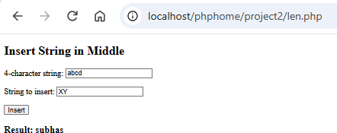

Question 26
Write a PHP program to create a new string from two given string one is shorter and another is longer. The format of the new string will be long string + short string + long string.

Code
<!DOCTYPE html>
<html>
<body>
<?php
$result = null;
if ($_SERVER['REQUEST_METHOD'] === 'POST') {
$a = $_POST['a'];
$b = $_POST['b'];

if (strlen($a) >= strlen($b)) {
$long = $a;
$short = $b;
} else {
$long = $b;
$short = $a;
}

$result = $long . $short . $long;
}
?>

<h2>Long + Short + Long</h2>
<form method="post">
First string: <input type="text" name="a" value="Hi" required><br><br> Second string: <input type="text" name="b" value="Welcome" required><br><br>
<button>Create</button>
</form>
<?php if ($result !== null) echo "<h3>Result: $result</h3>"; ?>
</body>
</html>

Output:
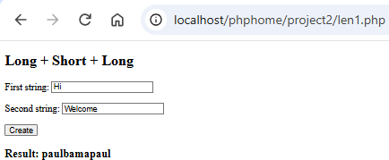

Question 27
Write a PHP program to rotate the elements of a given array of integers (length 4 ) in left direction and return the new array.

Code
<!DOCTYPE html>
<html>
<body>
<?php
$result = null;
if ($_SERVER['REQUEST_METHOD'] === 'POST') {
$arr = array_map('trim', explode(',', $_POST['arr']));
$first = array_shift($arr);
$arr[] = $first;

$result = implode(', ', $arr);
}
?>

<h2>Rotate Array Left</h2>
<form method="post">
4 integers (comma separated): <input type="text" name="arr" value="1,2,3,4" required><br><br>
<button>Rotate</button>
</form>
<?php if ($result !== null) echo "<h3>Result: [$result]</h3>"; ?>
</body>
</html>

Output:
